Automatic rewinding machine ZRJ-1300

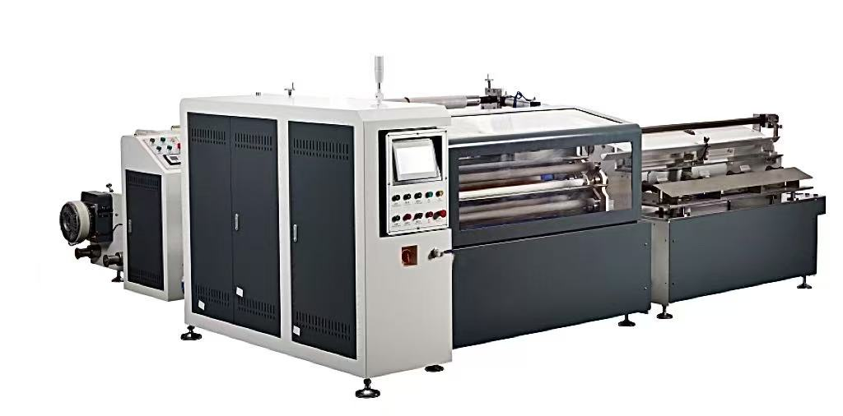
Equipment Layout:
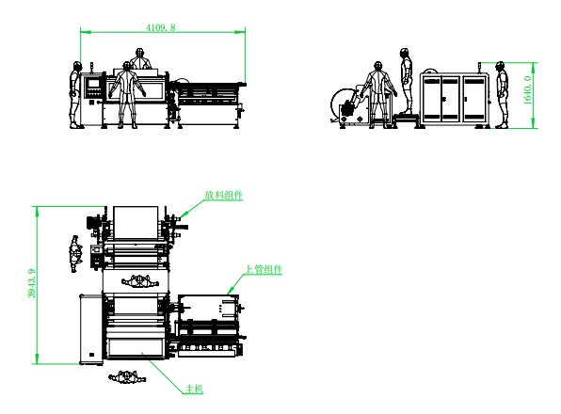
Basic Use：
Mainly used for kraft paper, and paper tape and other adhesive adhesive adhesive rewinding.
Product Characteristics：
- Hcfa motion control system, servo control of winding, servo control of active traction, servo control of label turnover, servo control of label pulling, servo control of discharge, servo control of winding press roller, servo control of cutting tool, servo control of waste collection, servo control of paper tube.
- High precision classifier transmission positioning structure, 4-axis automatic exchange, to achieve non-stop production, improve production efficiency.
- Automatic smoothing rods are added at winding and finishing points to ensure quick sealing without wrinkles.
- servo automatically shift the press roll to ensure the size of the gap between the press roll and the reel, so that the winding is more smooth.
- It can be rewound with rubber surface, can also peel back paper and receive material.
- Automatic loading tube, servo threading tube, automatic labeling, automatic cutting, automatic finishing, automatic discharge
- automatic tension release, stable tension, flat fit, stable start and stop. Edge control, winding flat.
- servo motor drawing, length calculation is accurate. Servo motor torque winding, winding tension is stable, accurate, winding exquisite work, flat end face
- can be rewound with rubber surface or stripped back paper. rewind with adhesive surface or peel off the base paper
- Unwinding using inflatable shaft, convenient and fast loading and unloading, cylinder lifting, automatic correction, unwinding magnetic powder brake winding automatic tension control, accurate control of torque.
- Tungsten steel round knife is used to cut the material, which is durable and neat.
- no film alarm, cut off alarm, no paper tube alarm stop.
- Using hcfa motion control system, one key start, easy to replace specifications.

Main Technical Parameters：
Model | ZRJ-1300
paper core | Customized according to customer requirements
Unwinding master roll | Max. Diameter 800mm
Rewinding diameter | 40-100mm
Rewind width | W（500-1300）mm
Production speed | 4-5pcs/MIN Depends on the rewinding length
power supply | 1P220V 50/60HZ/15KW
air pressure | 5KG
Machine size | 4110*3950*1650mm
Net Weight | 2000KG

Configuration Parameters：
model | ZRJ-1300
touch screen | 10 inches MCGS
Motion controller | HCFA
Active traction servo motor | HCFA
Active traction servo driver | HCFA
Label flip servo motor | HCFA
Label flip driver | HCFA
Pull-out servo motor | HCFA
Tag driver | HCFA
Discharge servo motor | HCFA
Discharge driver | HCFA
Coiling press roller servo motor | HCFA
Winding press roll driver | HCFA
Cutter servo motor | HCFA
Cutter driver | HCFA
Winding Servo Motor | HCFA
Winding Servo Drive | HCFA
Pipe threading servo motor | HCFA
Pipe threading servo driver | HCFA
Waste collection servo motor | HCFA
Waste servo drive | HCFA
Four-axis flip divider | JUJIU
stepper motor | Reiter
Stepper Motor Driver | Reiter
Tension controller | impqc
motor | sanly
Cutter motor | zhengk
reducer | Hasi Mai
Edge corrector | BIANFU
Magnetic powder clutch | WREZUN
air switch | chint
switching power supply | Mingwei
Stepper Motor Power Supply | Mingwei
Edge correction power supply | Mingwei
Linear guide | Rich
photoelectric sensor | BOJKE
Material detection sensor | BOJKE
Proximity Switch | Yangming
contactor | Schneider
relay | IDEA
Button switch | Schneider
Tri-color warning light | TAVB
Solenoid valve | asicko
Cylinder | STAR
Linear slide | HIWIN
Magnetic switch | AIRTAC
Unwinding, waste collection 3 inch gas expansion shaft | taiwan
bearing | NSK
Traction shaft | Nano coating for anti-sticking
Compression roll | PU adhesive
transition roller | Nano coating for anti-sticking
scalpel | 80MM Tungsten Carbide Circular Knife 100MM tungsten steel round knife

